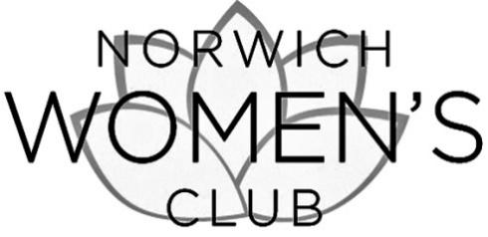

**Annual Membership Dues** (June 1, 2025 – May 31, 2026): **$25.00**

**Please [ ] Initiate [ ] Renew my membership**

COMPLETE THIS FORM AND MAIL,

WITH CHECK PAYABLE TO NORWICH WOMEN’S CLUB, TO:

NWC, PO BOX 191, NORWICH, VT 05055

Name: ....................................................................................................................................

Address: .................................................................................................................................

Phone (home): ...................................................... (cell): .........................................................

Email: ....................................................................................................................................

I want to make an additional tax-deductible contribution to support the Norwich Women’s Club:

Contribution to Community Projects Fund $..................

Contribution to Scholarship Fund $..................

Dues payment $ 25.00

____________

TOTAL ENCLOSED $...................

**Please make checks payable to the NORWICH WOMEN’S CLUB**

This gift is given

[ ] In memory of .....................................................

[ ] In honor of .........................................................

[ ] I wish my gift to be anonymous

YOU MAY ALSO PAY ONLINE AT WWW.NORWICHWOMENSCLUB.ORG